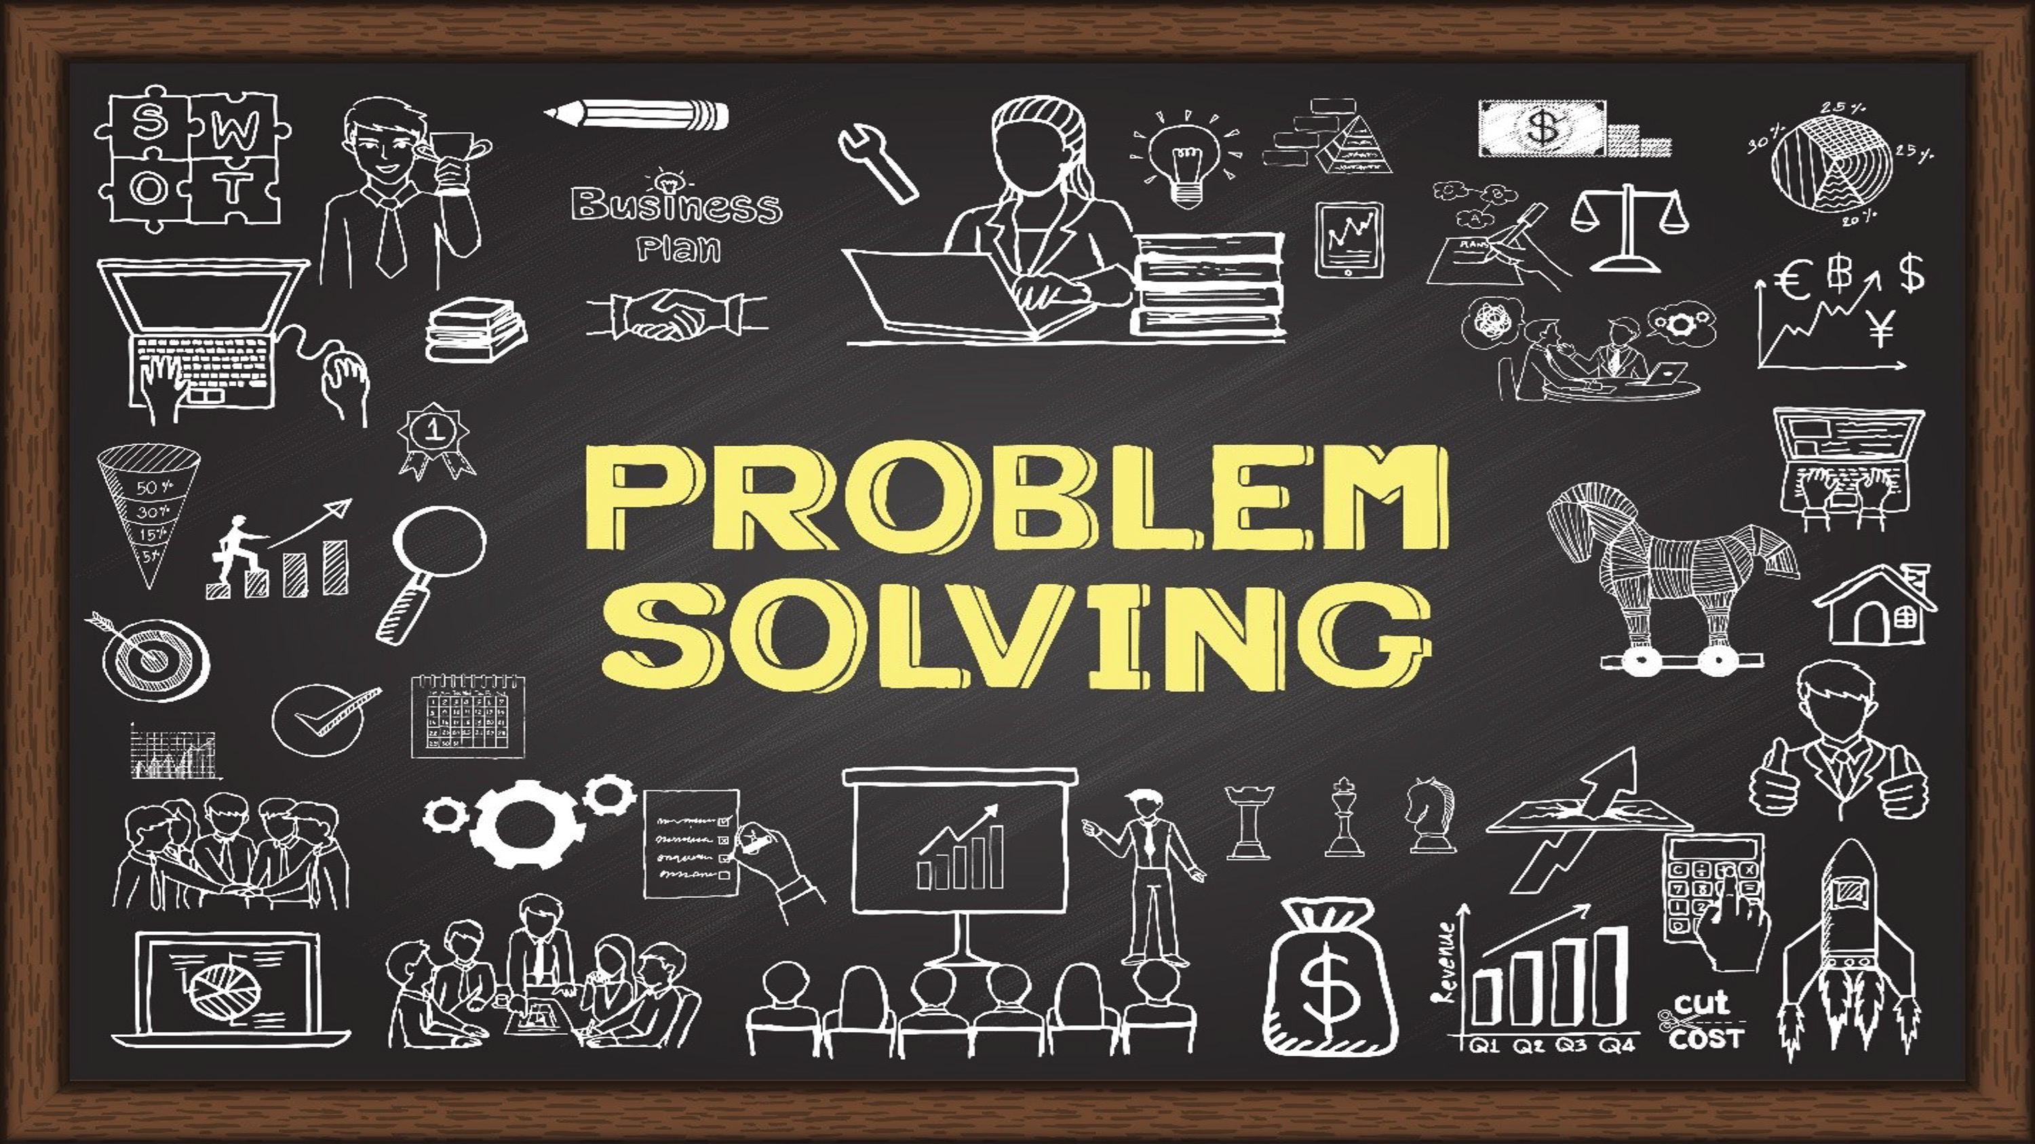

Step 1: Identity my problem ~ Keep asking why?

Step 2: How does this make me feel?

Step 4: What are my options?

Step 3: What are my goals?

Step 6: What actions do I need to take?

Step 5: What options align with my goals?

Step 8: Reflect - How would I feel if my actions gave me the results that I want?

Step 7: Results - What would my results look like?

